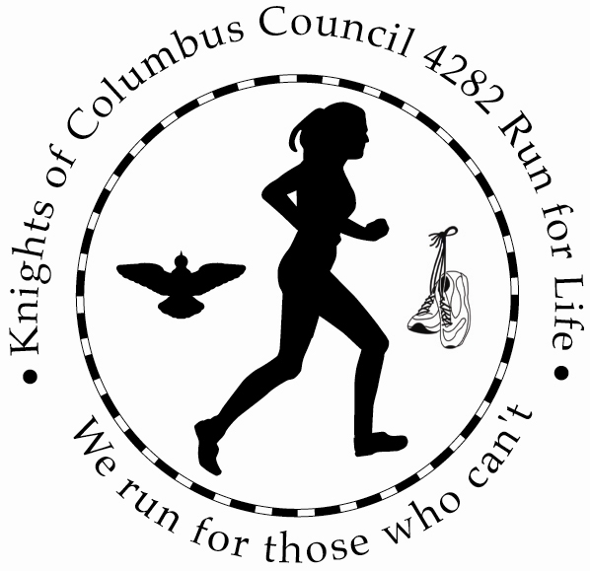

5K/Walk
Saturday June 20, 2015
9AM

I would like to volunteer for this year’s Knights of Columbus Council 4282 Run for Life!
All proceeds from the 5K run/Walk will benefit Save the Storks and Mary’s shelter.

Return this completed form by mail to: DeDe Brown, 100 E High Street , Nazareth PA 18064
Or
e-mail to liferunners2014@gmail.com by June 1, 2015.

All Volunteers will receive a t-shirt the day of the event.

Volunteer:____________________________________________ Age is younger that 18 _________

T-Shirt Size (Circle one) S M L XL

Address:_____________________________________________________________________________________

Phone:_____________________________________________

E-mail:____________________________________________

Volunteer tasks willing to perform: (please check all that apply):

____ Course Worker

_____ Sign Up Registration

_____ Start/Finish Line worker

_____ First Aid

______ Water/Food Station

_____ Clean Up

___ Put up Posters

____ Solicate Sponsors

____ Promotion

__ General

___ Thank You Notes to Sponsors

