2nd Annual
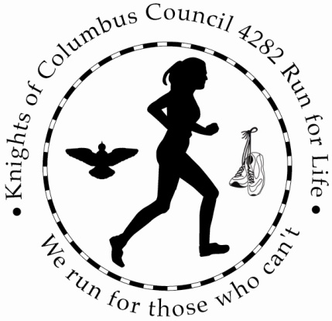
5K Run/Walk
Saturday, June 20th, 2015
Notre Dame High School
3417 Church Road, Easton, PA 18045
Race Starts at 9 AM
Registration: 8-8:45 AM

Proceeds will be split between: Save the Storks and Mary’s Shelter in Bethlehem

ENTRY FEE:
Registration postmarked before May 20th: $20
Registration postmarked after May 20th - $25
Race Day: $30

New This Year! STUDENT RATE (18 years old and younger)
Registration postmarked before May 20th: $15
Registration postmarked after May 20th - $20
Race Day: $30

T-Shirts will be guaranteed for everyone registered prior to May 20th, 2015.

Awards will be given to the following Male and Female groups:
Overall Male and Overall Female
12 AND UNDER, 13-17 18-29, 30-39, 40-49, 50-59, 60+

The Course is an established route through Bethlehem Township. It is flat and fast and a great place to achieve your personal record!
Race Day Registration packets/t-shirts may be picked up Friday, June 19, 2015 at 100 E High Street Nazareth., PA 18064 between 6-7PM and at race site between 8 AM and 8:45 AM on race day.

Results will be posted on: www.alphaandomegasports.com

Please fill out completely the form on the back and sign waiver

NAME: ___________________

Sex: (Circle) M or F Age:

Email:

Phone:

Address:

T-Shirt Size (please circle one) S M L XL

Waiver: I know that running a road race is a potentially hazardous activity. I should not enter and run unless I am medically able and properly trained. I also know that there will be traffic on the course and assume the risk of running in traffic. I also assume any and all other risks associated with running or attending the race including but not limited to falls, contact with other participants, the effects of the weather and the condition of the roads, all such risks being known and appreciated by me. Knowing these facts, and in consideration of your accepting my entry fee, I hereby, for myself, my heirs, executors, administrators or anyone else who might claim on my behalf, covenant not to sue, and waive, release and discharge Knights of Columbus Council 4282 and/or DeDe Brown and/or Alpha & Omega Sports, any subcontractors it utilizes, all municipalities in which the race is held, the race committee, volunteers, any and all sponsors including their agents, employees, assigns or anyone acting for their behalf, or anyone else associated in any way with the race, from any or all claims or liability for death, personal injury or property damage of any kind of nature what so ever arising out of or in the course, my participation in this event. This waiver extends to all claims of every kind of nature what so ever, foreseen or unforeseen, known or unknown. By entering this race, I am granting permission to Alpha and Omega Sports and Knights of Columbus Council 4282 and/or DeDe Brown and/or to use any pictures or likeness of me secured at the event in any way they see fit without review, restriction or compensation. I HAVE READ AND UNDERSTAND THIS WAIVER. (if under 18 legal guardian must sign)

NAME:______________________________ SIGNATURE:__________________________

Make Checks payable to DeDe Brown with “Run for Life” in the memo line

Please send all registration forms and payments to:
DeDe Brown
100 E High Street
Nazareth, PA 18064-1516

OR register on-line at www.alphaandomegasports.com and click “Race Calendar”

Registration forms may also be downloaded at:
http://knightsofcolumbusrunforlife.weebly.com/

